**DYNAMIC PARAMETERIZE LINKED SERVICES WITH METADATA MANAGEMENT**

 Below is the High-Level Approach we have chosen to go with:

***Requirement:***

          The requirement was to load the data from source systems and incrementally load into the destination system tables. In this process we have to take up multiple source systems and destination systems.

***Existing Solution:***

          The existing solution is to load the data from multiple tables from source system to the destination system on a periodic mode(Daily, Weekly) using Azure Data Factory V2.  For this everything is defined manually by creating the queries, table datasets connections. We have created multiple pipelines ( 40 Pipelines) and around 80 Datasets for this process. Atlast all this have been consolidated to flow in a sequence. We didn’t have any approach to dynamically handle the connections and the datasets.

***New Approach:***

          We have decided to scrap the existing approach if we are able to successfully build the dynamic approach and we are in this process of implementing it . By this process we will only have 2 Pipelines and 2 Data Sources . Below are the steps for the process :

***Handling Multiple Tables of Source & Destination Dynamically :***

1. Create a Metadata Table which will have information about the Source System , Tables , Destination System and its tables as below :

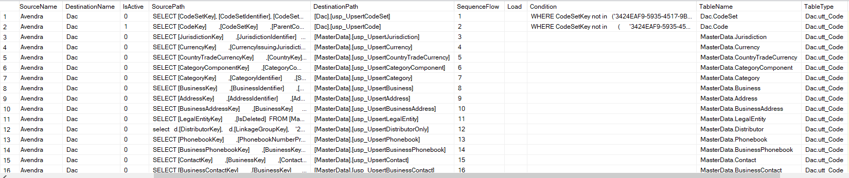

1. Calling the metadata table from ADF Lookup and iterating the flow . By this we are able to remove 80+ datasets and 35+ Pipelines to have 2 Pipelines and 2 Datasets . Below is the architecture which will iterate the above table and load the data sequentially.

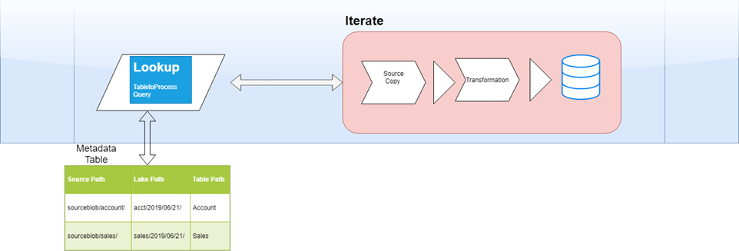

***Handling Dynamic Datasets & Connections :***

1. For handling the dynamic connections to the datasets and also defining the datasets for dynamically reading the DEV and PROD Connections below is the approach we are implementing . We tested with sample data and it worked as expected.

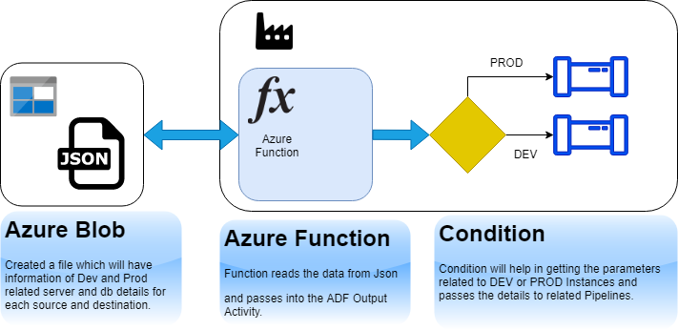

1. Created a json file which will have connection strings for Dev & Prod.
2. We are using Azure Function to call the parameters from the json file dynamically based on Dev / Prod.
3. Based on the type of Source (Dev/Prod) , we are defining conditional navigation for pipelines according.

This way we can automate the complete process and also it doesn’t impact the dev prod migration and deployment.

***Advantages :***

1. Less Code and more robust approach .
2. Any change in the system will not impact the pipeline .
3. Completely parameterized which will help in creating this as a template .
4. We can rebuild any such requirements from here for any client . 2-3 weeks of data migration can be possible(We can pitch this approach as template and do POCs in 2 weeks)
5. Easily migrate from Dev to Prod or any subscription .